Assignment -3
Python Programming

Assignment Date | 06 October 2022
Student Name | S.DIVYADHARSHINI
Student Roll Number | 811519106040
Maximum Marks | 2 Marks

Question-1:
Write a python code for led blinking in raspberry pi SOLUTION:
import RPi.GPIO as GPIO # Import Raspberry Pi GPIO library
from time import sleep # Import the sleep function from the time module

GPIO.setwarnings(False) # Ignore warning for now GPIO.setmode(GPIO.BOARD) # Use physical pin numbering
GPIO.setup(8, GPIO.OUT, initial=GPIO.LOW) # Set pin 8 to be an output pin and set initial value to low (off)

while True: # Run forever GPIO.output(8, GPIO.HIGH) # Turn on sleep(1) # Sleep for 1 second GPIO.output(8, GPIO.LOW) # Turn off sleep(1) # Sleep for 1 second

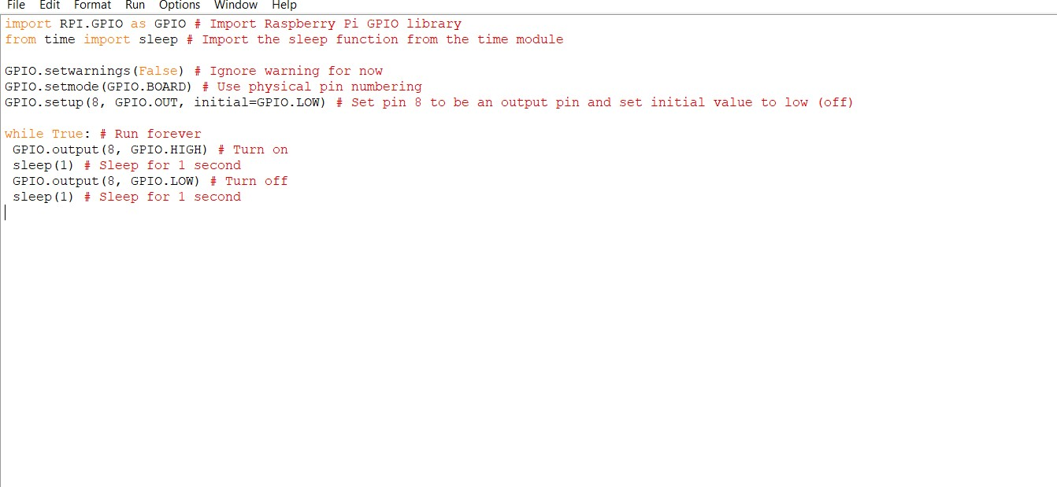

Question-2:
Write a python code for traffic light in raspberry pi SOLUTION:
from gpiozero import Button, TrafficLights, Buzzer from time import sleep

buzzer = Buzzer(15) button = Button(21)
lights = TrafficLights(25, 8, 7)

while True:
button.wait_for_press() buzzer.on() light.green.on() sleep(1) lights.amber.on() sleep(1)
lights.red.on() sleep(1) lights.off() buzzer.off()

